|  |  |
| --- | --- |
| < Home security system > | Version < 1.0> |
| Using Internet Of Things | <date> |
| < > |  |

<Developer Squad>

**Home Security System**

**Using Internet Of Things**

Version < 1.0>

**Team Guide:** Mr. Rajesh Bhatija Sir

**Members:** Shipra Goyal, Radhey Shyam Sen, Saurabh Singh, Rishabh Anand, Gaurav Gupta, Sanghamitra Johri.

College Name: JECRC Foundation Jaipur

Department: Electronics And Communications Department and IT

State: Rajasthan

|  |  |
| --- | --- |
| < Project scenario name > | Version <X.0> |
| Software Requirements Specification | <date> |
| <team name> |  |

**Revision History**

|  |  |  |  |
| --- | --- | --- | --- |
| **Date** | **Version** | **Description** | **Author** |
| <date> | 1.0 | Synopsis | <team name> |
| <date> | 2.0 | Synopsis | <team name> |
|  |  |  |  |

Page 2

|  |  |
| --- | --- |
| < Project scenario name > | Version X.0 |
| Software Requirements Specification | <date> |
| <team name> |  |

**Table of Contents**

**Description** **Page**

**1.0 Introduction** **No.**

* + 1. Purpose
    2. Scope
    3. Definition, Acronyms, and Abbreviations
    4. References
    5. Technologies to be used
    6. Overview

1. **Overall Description** 
   1. Product Perspective
   2. Software Interface
   3. Hardware Interface
   4. Product Function
   5. User Characteristics
   6. Constraints
   7. Architecture Design
   8. Use Case Model Description

|  |  |
| --- | --- |
| < Project scenario name > | Version X.0 |
| Software Requirements Specification | <date> |
| <team name> |  |

* + 1. Class Diagram ........................................................................

Sequence Diagram s ...............................................................

* + 1. Database Design ....................................................................
       1. ER Diagram...............................................................
       2. Schema ......................................................................
  1. Assumptions and Dependencies

1. **Specific Requirements** 
   * 1. Use Case Reports
     2. Supplementary Requirements

|  |  |  |
| --- | --- | --- |
|  |  | |
|  |  |  |
| < Project scenario name > |  | Version X.0 |
| Software Requirements Specification |  | <date> |
| <team name> |  |  |

**Software Requirements Specification**

1.1 **Introduction :** The Internet of things (IoT) is the system of physical gadgets, vehicles, home apparatuses and different things implanted with hardware, programming, sensors, actuators, and system network which empowers these articles to associate and trade data. Each thing is remarkably identifiable through its installed figuring framework however can between work inside the current Internet foundation. Specialists assess that the IoT will comprise of around 30 billion protests by 2020.It is additionally evaluated that the worldwide market estimation of IoT will reach $7.1 trillion.

The IoT enables articles to be detected or controlled remotely crosswise over existing system infrastructure, making open doors for more straightforward joining of the physical world into PC based frameworks, and bringing about enhanced productivity, precision and financial advantage notwithstanding lessened human intervention. When IoT is increased with sensors and actuators, the innovation turns into an example of the more broad class of digital physical frameworks, which additionally includes advancements, for example, keen matrices, virtual power plants, savvy homes, wise transportation and brilliant urban communities.

“Things", in the IoT sense, can allude to a wide assortment of gadgets, for example, heart checking inserts, biochip transponders on cultivate creatures, cameras gushing live encourages of wild creatures in waterfront waters,vehicles with worked in sensors, DNA investigation gadgets for ecological/sustenance/pathogen monitoring, or field operation gadgets that help firefighters in hunt and save operations.Legal researchers recommend in regards to "things" as an "inseparable blend of equipment, programming, information and service".These gadgets gather valuable information with the assistance of different existing advances and after that independently stream the information between other devices.

1.2 Purpose:

With the advanced development of internet computing, various systems can be easily accessed and remotely controlled through mobile devices. In this era self-build make it possible to solve. The current security lock system has three main problems which are insecure, unawareness of break-ins and inconvenience by ourselves by using home automation technologies. Conventional lock is easy to lock picking and leaves home vulnerable to break-ins. Second, the home owners are often unaware during their homes are being break-in when they are at work or away from home. Lastly, physical keys are bulky and inconvenient to carry. To solve these issues, we have developed an inexpensive smart home security lock system using RFID as the main access of the door, a web- based control and notification system.

1.3 Scope: The Home Security System includes:

Security is a big challenge everywhere because thefts are increasing day by day owing to the unsafe and insecure security systems in homes, commercial complexes and industries. Several conventional technologies are available to keep home properties safe from intruders, but most common smart home security systems work on wireless GSM communication. Such systems provide security from natural, incidental, intended, unintended, accidental and human made problems by continuously monitoring homes with different sensory systems like motion, smoke, gas, temperature, glass break or door break detectors and fire alarm systems.

**1.4** Definitions, Acronyms, and Abbreviations: .

DB2 (IBM Database 2): It is a database management system that provides a flexible and efficient database platform to raise a strong "on demand" business applications.

1. References:

* Wikipidea
* Engineersgarage
  1. Technologies to be used:
     + - RF module
       - Arduino
       - Node mcu esp8266
       - Database Server

|  |  |  |
| --- | --- | --- |
| < Project scenario name > | Version X.0 | |
|  |  |  |
| < Project scenario name > |  | Version X.0 |
| Software Requirements Specification |  | <date> |
| <team name> |  |  |

1. **Overall Description:**
2. Product Perspective:

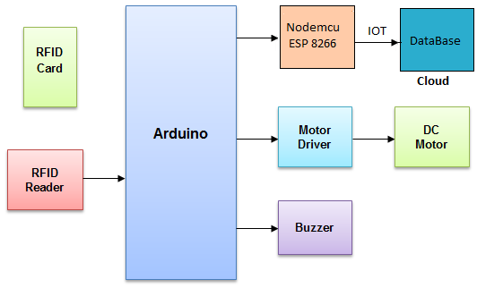

1. Software Interface:

-I- **Front End Client: Atmel studio, eclipse, python IDLE.**

-I- **Data Base Server: sql.**

4- **Back End:Embedded C.**

|  |  |
| --- | --- |
| < Project scenario name > | Version X.0 |
| Software Requirements Specification | <date> |
| <team name> |  |

**2.3** Hardware Interface:

* Atmega 16
* Ardino
* Rasberry Pi
* Motor
* RFID card/module
* Ethernet/wifi
  + 1. Product Functions:.

1. **RFID Card :**

Radio-frequency identification (RFID) uses [electromagnetic fields](https://en.wikipedia.org/wiki/Electromagnetic_field) to automatically identify and track tags attached to objects. The tags contain electronically stored information. Passive tags collect energy from a nearby RFID reader's interrogating [radio waves](https://en.wikipedia.org/wiki/Radio_waves). Active tags have a local power source (such as a battery) and may operate hundreds of meters from the RFID reader. Unlike a [barcode](https://en.wikipedia.org/wiki/Barcode), the tag need not be within the line of sight of the reader, so it may be embedded in the tracked object. RFID is one method for [Automatic Identification and Data Capture](https://en.wikipedia.org/wiki/Automatic_Identification_and_Data_Capture) (AIDC).[[1]](https://en.wikipedia.org/wiki/Radio-frequency_identification#cite_note-1)

RFID tags are used in many industries, for example, an RFID tag attached to an automobile during production can be used to track its progress through the assembly line; RFID-tagged pharmaceuticals can be tracked through warehouses; and [implanting RFID microchips](https://en.wikipedia.org/wiki/Microchip_implant_(animal)) in livestock and pets allows for positive identification of animals.

1. **RFID Reader :**

A radio frequency identification reader (RFID reader) is a device used to gather information from an RFID tag, which is used to track individual objects. Radio waves are used to transfer data from the tag to a reader.  
RFID is a technology similar in theory to bar codes. However, the RFID tag does not have to be scanned directly, nor does it require line-of-sight to a reader. The RFID tag it must be within the range of an RFID reader, which ranges from 3 to 300 feet, in order to be read. RFID technology allows several items to be quickly scanned and enables fast identification of a particular product, even when it is surrounded by several other items.  
RFID tags have not replaced bar codes because of their cost and the need to individually identify every item.

1. **Arduino :**

Arduino is an open-source electronics platform based on easy-to-use hardware and software. [Arduino boards](https://www.arduino.cc/en/Main/Products) are able to read inputs - light on a sensor, a finger on a button, or a Twitter message - and turn it into an output - activating a motor, turning on an LED, publishing something online. You can tell your board what to do by sending a set of instructions to the microcontroller on the board. To do so you use the [Arduino programming language](https://www.arduino.cc/en/Reference/HomePage) (based on [Wiring](http://wiring.org.co/)), and [the Arduino Software (IDE)](https://www.arduino.cc/en/Main/Software), based on [Processing](https://processing.org/). Over the years Arduino has been the brain of thousands of projects, from everyday objects to complex scientific instruments. The Arduino Software (IDE) is easy-to-use for beginners, yet flexible enough for advanced users to take advantage of as well. For teachers, it's conveniently based on the Processing programming environment, so students learning to program in that environment will be familiar with how the Arduino IDE works.

**NodeMcu esp8266-**

NodeMCU Board is based on widely explored esp8266 System on Chip from Expressif. It combined features of WIFI accesspoint and station + microcontroller and uses simple [LUA](http://www.lua.org/) based programming language. ESP8266 [NodeMCU](http://nodemcu.com/index_en.html#fr_54747361d775ef1a3600000f) offers-

--Arduino-like hardware IO

--Event-driven API for network applicaitons

--10 GPIOs D0-D10, PWM functionality, IIC and SPI communication, 1-Wire and ADC A0 etc. all in one board

--Wifi networking (can be uses as access point and/or station, host a web server), connect to internet to fetch or upload data.

--excellent few system on board for Internet of Things (IoT) projects.

Recently, there has been interest in programming ESP8266 systems using Arduino IDE. Programming, of ESP8266 using Arduino IDE is not very straight forward, until it is properly configured. Especially because, the Input and output pins have different mapping on NodeMCU than those on actual ESP8266 chip.

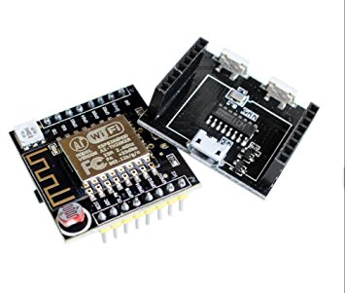

1. **Motor Driver :**

A motor driver is a little current amplifier; the function of motor drivers is to take a low-current control signal and then turn it into a higher-current signal that can drive a motor. Motor driver is a dual full-bridge driver designed to drive inductive loads such as relays, solenoids, DC and stepping motors. It lets you drive two DC motors with your Arduino board, controlling the speed and direction of each one independently.

1. **Buzzer :**

A buzzer or beeper is a signalling device, usually electronic, typically used in automobiles, household appliances such as a microwave oven, or game shows. It most commonly consists of a number of switches or sensors connected to a control unit that determines if and which button was pushed or a preset time has lapsed, and usually illuminates a light on the appropriate button or control panel, and sounds a warning in the form of a continuous or intermittent buzzing or beeping sound. Initially this device was based on an electromechanical system which was identical to an electric bell without the metal gong (which makes the ringing noise). Often these units were anchored to a wall or ceiling and used the ceiling or wall as a sounding board. Another implementation with some AC-connected devices was to implement a circuit to make the AC current into a noise loud enough to drive a loudspeaker and hook this circuit up to a cheap 8-ohm speaker. Nowadays, it is more popular to use a ceramic-based piezoelectric sounder like a Sonalert which makes a high-pitched tone. Usually these were hooked up to "driver" circuits which varied the pitch of the sound or pulsed the sound on and off.

1. **DataBase :**

A database is a collection of [information](http://searchsqlserver.techtarget.com/definition/information) that is organized so that it can be easily accessed, managed and updated. Data is organized into rows, columns and tables, and it is indexed to make it easier to find relevant information. Data gets updated, expanded and deleted as new information is added. Databases process workloads to create and update themselves, querying the data they contain and running applications against it.

1. **DC Motor :**

A DC engine is any of a class of rotational electrical machines that proselytes coordinate current electrical vitality into mechanical vitality. The most widely recognized composes depend on the powers created by attractive fields. About a wide range of DC engines have some inner system, either electromechanical or electronic, to intermittently alter the course of current stream in part of the engine

DC engines were the principal write broadly utilized, since they could be fueled from existing direct-current lighting power dispersion frameworks.

* + 1. User Characteristics:

In reality we usually see two kind of people, one of them is authorized to access something and other are trying to access it. This system is systematically designed to overcome the problem of unauthorized access to particular lock. In this system user usually presents his RF ID card which simply contains a number which intern contains all the information related to the user in the system, after presenting card to the system, the system gets a particular number linked to that card after this the system verifies and provides authentication/ de-authentication depending upon the validity of the card.

* + - * 1. Constraints:
    - power supply is nessasry.
    - RFID card is required
    - Internet connection is required.

* + - 1. Architecture Design:

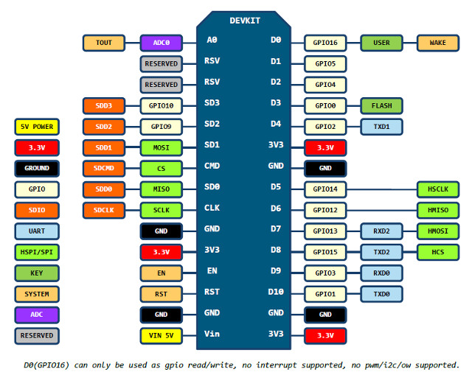

* + - 1. Use Case Diagram :

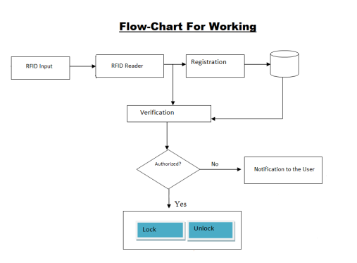

1. **Specific Requirements:** 
   1. **Supplementary Requirements:**

**Raspberry-pi :-**

The Raspberry pi is an ease single board minicomputer which can be utilized for taking in the PC nuts and bolts, programming and simple to interface with the implanted frameworks. The Raspberry pi is a smaller than normal PC which is planned in a solitary board with all the fundamental segments required for running a working framework. The Raspberry pi board keeps running on ARM11 processor yet is accessible at greatly shoddy cost. The board is given a RCA connector which can be utilized to associate it straightforwardly to a TV screen which depends on PAL and NTSC standard. The board likewise has a HDMI connector yield which can be utilized to interface the board to a HD 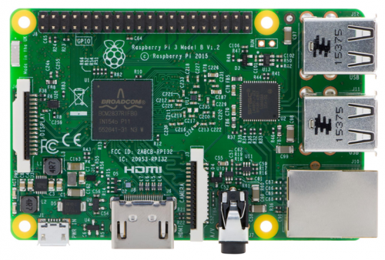

The board has two USB2 ports where the console and mouse can be connected to. There is an Ethernet port which can be utilized to interface the board to a PC arrange. A video input port is likewise accessible with a Raspberry pi board which can be utilized to associate an outside camera. The board likewise has a SD card space and the Raspberry pi is intended to boot from the SD card.

The Raspberrypi board can boot various working frameworks like Archlinux ARM, OpenELEC, Pidora, Raspbmc, RISC OS and the Raspbian and furthermore Ubuntu. A well ordered clarification of how to introduce Ubuntu in the Raspberrypi board is accessible in a past article. In the wake of booting the Ubuntu without precedent for Raspberrypi it must be arranged so it can utilize every one of the highlights of the Raspberrypi board.

DC MOTORS

A DC engine is any of a class of rotational electrical machines that proselytes coordinate current electrical vitality into mechanical vitality. The most widely recognized composes depend on the powers created by attractive fields. About a wide range of DC engines have some inner system, either electromechanical or electronic, to intermittently alter the course of current stream in part of the engine

DC engines were the principal write broadly utilized, since they could be fueled from existing direct-current lighting power dispersion frameworks. A DC engine's speed can be controlled over a wide range, utilizing either a variable supply voltage or by changing the quality of current in its field windings. Little DC engines are utilized as a part of devices, toys, and machines. The widespread engine can work on coordinate current yet is a lightweight engine utilized for convenient power apparatuses and machines. Bigger DC engines are utilized as a part of impetus of electric vehicles, lift and raises, or in drives for steel moving plants. The coming of energy gadgets has made supplanting of DC engines with AC engines conceivable in numerous applications.